# LATTHE EDUCATION SOCIETY’S POLYTECHNIC, SANGLI



**DEPARTMENT OF COMPUTER ENGINEERING**

# MICRO PROJECT REPORT

**SUBJECT: Software Testing**

# TITLE: Develop a Course Registration Form

# And Write test cases on it.

**SUBMITTED BY:**

|  |  |  |
| --- | --- | --- |
| **Roll Number** | **Name** | **Enrollment Number** |
| 243205 | Raghav Deepak Dattawadkar | 2200430300 |

**Rationale**

The objective of this micro project is to develop a functional and user-friendly **Course Registration Form** for students to enroll in courses efficiently. This project is designed to simulate real-world scenarios where students need to register for courses in an academic environment, such as colleges or universities.

By developing this form, I aim to demonstrate the following skills:

* **Form Design and Layout**: Create an intuitive form where students can input essential details like name, student ID, course selection, and contact information.
* **Validation and Data Handling**: Implement basic JavaScript for form validation, ensuring that all required fields are filled out correctly before submission.
* **User Experience (UX)**: Ensure that the form is easy to use and provides feedback for users when errors occur.

### **Writing Test Cases**

After developing the form, I will create **test cases** to verify the functionality of each part of the form. This will involve:

1. Testing if all required fields are working correctly.
2. Ensuring validation (e.g., correct email format, non-empty fields).
3. Checking that the form submits successfully when valid data is entered.
4. Testing error messages for incorrect or missing input.
5. Verifying that the user receives confirmation after successful submission.

**Aim of the Microproject**

The aim of this micro project is to **Develop a Course Registration Form** that allows students to easily register for courses online. I will also **write test cases** to check if the form works correctly, ensuring that all the fields are properly validated, and that the form can be submitted without any issues. This project will help me learn how to create simple web forms and test their functionality.

**Course Outcomes Addressed**

* **Understand Form Design**: I will learn how to create a well-structured and easy-to-use course registration form.
* **Implement Form Validation**: I will gain experience in using basic JavaScript to ensure the form collects correct and complete information.
* **Test Functionality**: I will learn how to write test cases to check if the form works as expected, including checking validation and submission.
* **Problem-Solving Skills**: I will improve my ability to identify and fix issues during the form development and testing process.
* **Real-World Application**: I will understand how course registration forms work in academic settings, preparing me for similar tasks in the future.

**Resources Required**

|  |  |  |  |
| --- | --- | --- | --- |
| **Sr No.** | **Name of resource/material** | **Specifications** | **Remark** |
| 1 | Computer System | Intel Core i5 and RAM 8GB Windows 11 | 1 |
| 2 | Software | Visual Studio Code | 1 |
| 3 | And other resources used | Laser Printer HP LaserJetPro P1566 Printer | 1 |

**Actual Methodology Followed**

• **Understanding the Requirements**: First, I identified what details the course registration form should collect, such as student name, student ID, course selection, email, and contact information.

• **Designing the Form**: I created a simple and clean layout for the form using HTML. Each field was added with proper labels for easy understanding by users.

• **Adding Validation**: I used JavaScript to validate the form. This included checking if required fields were filled, ensuring the email was in the correct format, and confirming that all input was correct before submitting the form.

• **Writing Test Cases**: After building the form, I wrote test cases to check the following:

* Whether the form works correctly when valid data is entered.
* How it handles errors when fields are left empty or have invalid data.
* If appropriate error messages are shown to the user.

• **Testing and Debugging**: I tested the form using different inputs to ensure everything was working as expected. When errors were found, I debugged and fixed them.

• **Final Testing**: Once all issues were resolved, I conducted a final round of testing to confirm the form was working smoothly and could be submitted without problems.

**Source Code**

<!DOCTYPE html>

<html lang="en">

<head>

<meta charset="UTF-8">

<meta name="viewport" content="width=device-width, initial-scale=1.0">

<title>Course Registration Form</title>

<link rel="stylesheet" href="formstyle.css">

<link rel="preconnect" href="https://fonts.googleapis.com">

<link rel="preconnect" href="https://fonts.gstatic.com">

<script>

function savedata() {

// Object Creation.

var name = document.getElementById('Name');

var errorname = document.getElementById('errorname');

var email = document.getElementById('Email');

var mobile = document.getElementById('MobileNo');

var errormobile = document.getElementById('errormob');

var pwd = document.getElementById('pwd');

name.style.backgroundColor = "white";

email.style.backgroundColor = "white";

mobile.style.backgroundColor = "white";

pwd.style.backgroundColor = "white";

errorname.innerHTML = "";

errormobile.innerHTML = "";

if (name.value.trim() == "") {

name.style.backgroundColor = "rgb(255, 215, 215)";

name.focus();

errorname.innerHTML = "Please Enter The Name";

errorname.style.color = "red";

return;}

if (email.value.trim() == "") {

email.style.backgroundColor = "rgb(255, 215, 215)";

email.focus();

return;}

if (mobile.value.trim() == "") {

mobile.style.backgroundColor = "rgb(255, 215, 215)";

mobile.focus();

return;

}

if (pwd.value.trim() == "") {

pwd.style.backgroundColor = "rgb(255, 215, 215)";

pwd.focus();

return;

}

alert("Registration Successful");

}

</script>

</head>

<body>

<div class="container">

<div class="form-box">

<div class="Heading">

<h2>Registration Form</h2>

</div>

<form class="input-group" action="connectdiploma.php" method="post">

<label class="form-label">Enter Name</label>

<input type="text" placeholder="Enter Your Name" id="Name" name="Name" required>

<br>

<div id="errorname"></div>

<label class="form-label">Enter Email</label>

<input type="email" placeholder="Enter Your Email" id="Email" name="Email" required>

<br>

<label class="form-label">Enter Mobile No</label>

<input type="number" placeholder="Enter Your Mobile" id="MobileNo" name="MobileNo" required>

<div class="errormob"></div>

<br>

<label class="form-label">Enter Password</label>

<input type="password" placeholder="Enter Password Here" id="pwd" name="pwd" required>

<br><br>

<label class="form-label" style="margin-right: 20px;">Select Year</label>

<select name="year" id="year">

<option value="First Year">First Year</option>

<option value="Second Year">Second Year</option>

<option value="Third Year">Third Year</option>

</select>

<br><br>

<label class="form-label">Select Course</label>

<select name="course" id="course">

<option value="Languages">Languages</option>

<option value="Web Technology">Web Technology</option>

<option value="Data Structure">Data Structure</option>

</select>

<div class="button-container">

<button type="submit" class="submit-btn" onclick="savedata()">Register</button>

<button type="button" class="back-btn" onclick="back()">Back</button>

</div>

</form>

</div>

</div>

</body>

</html>

**Output of the Project**

**Login Page GUI:-**

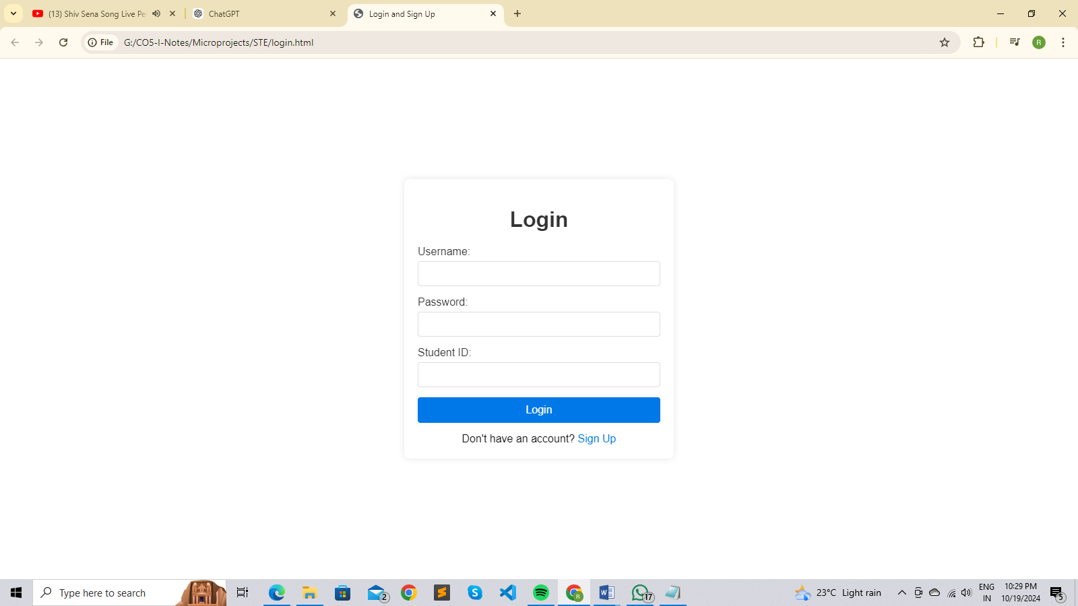

**Login Page Validation:-**

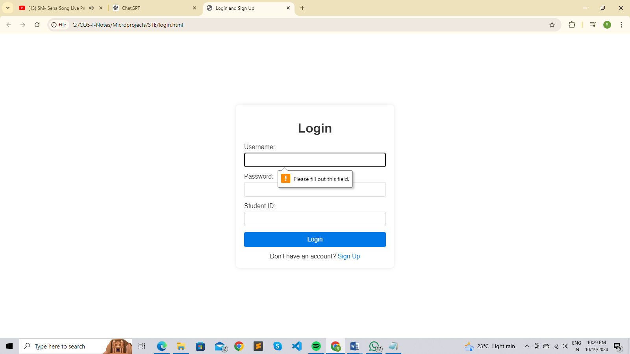

**Data Fill In Login Page:-**

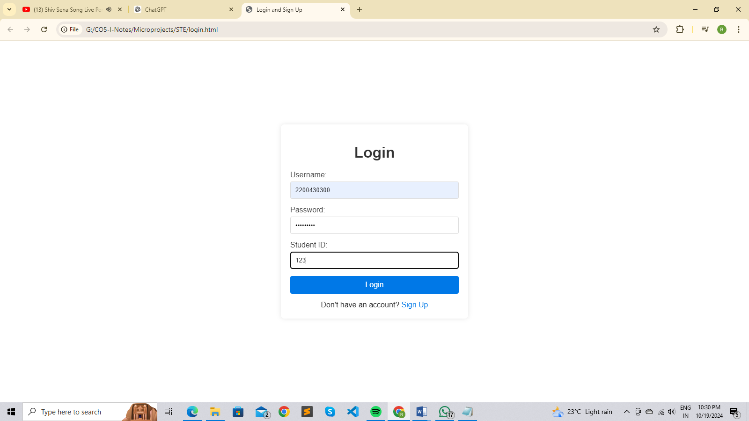

**Course Registration Form GUI:-**

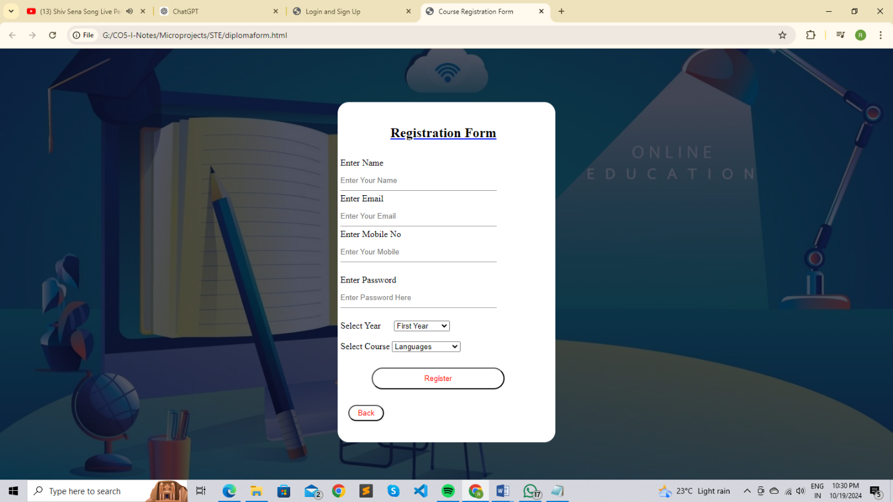

**Course Registration Form Validation:-**

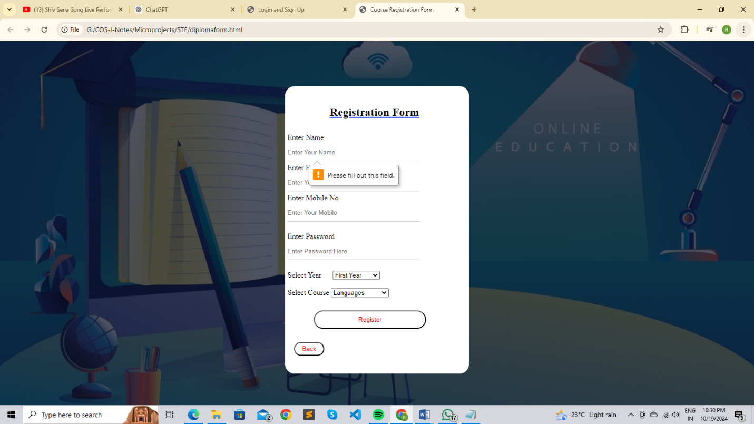

**Data Fill In Course Registration Form:-**

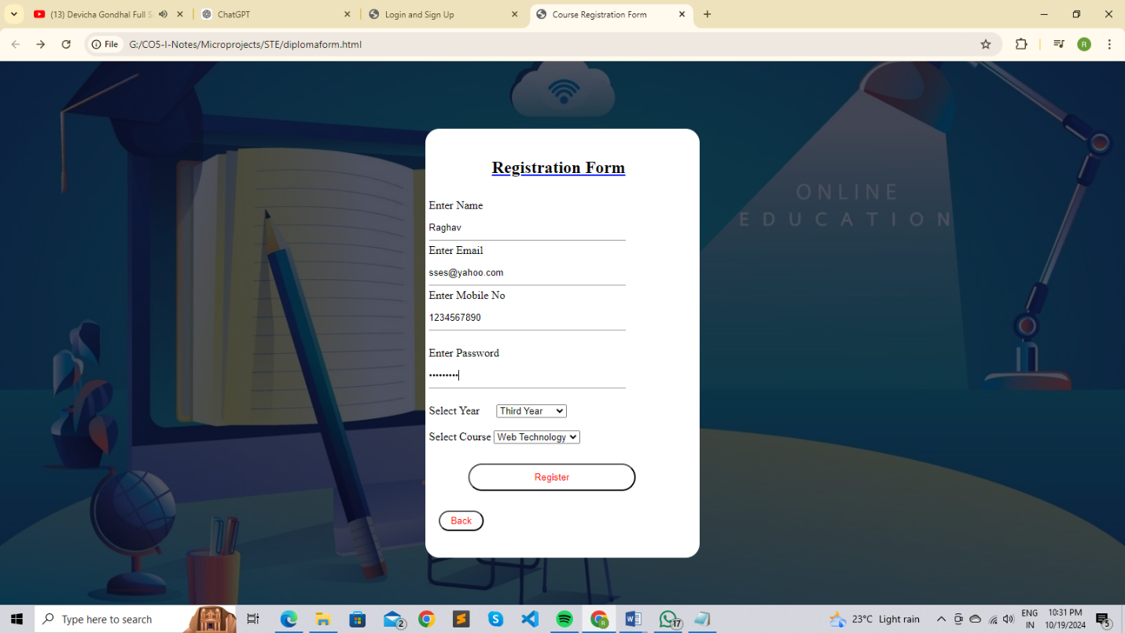

**Test Cases**

**Test Case on Login Page:-**

|  |  |  |  |  |  |  |
| --- | --- | --- | --- | --- | --- | --- |
| **Test Case ID** | **Test Case Name** | **Steps** | **Input Data** | **Expected Result** | **Actual Result** | **Status** |
| TC_1 | Username | Enter the username in alphabet | “Raghav” | Username should be accepted | Accepted | Pass |
| TC_2 | Password | Enter your 8 digit password | xyz@1234 | Password should be accepted | Accepted | Pass |
| TC_3 | Login | Click on login button | Click event | It should go to next page | Accepted | Pass |
| TC_4 | Sign up | Click on sign up | Click event | It should go to signup page | Accepted | Pass |
| TC_5 | Username | Enter the new username in alphabet | “Raghav” | Username should be accepted | Accepted | Pass |
| TC_6 | Password | Enter your new 8 digit password | xyz@1234 | Password should be accepted | Accepted | Pass |
| TC_7 | Sign up | Click on sign up button | Click event | It should be sign up your account | Accepted | Pass |

**Test Case On Course Registration Form:-**

|  |  |  |  |  |  |  |
| --- | --- | --- | --- | --- | --- | --- |
| **TC ID** | **TC Name** | **Steps** | **Input Data** | **Expected Result** | **Actual Result** | **Status** |
| TC_8 | Name | Enter the name in alphabet | “Raghav” | Name should be accepted | Accepted | Pass |
| TC_9 | Email | Enter Email in string which include alphabets,number,@ and . | “abc123@gmail,com” | Email should be accepted | Accepted | Pass |
| TC_10 | Mobile No | Enter 10 Digit Valid Mobile No | 1234567890 | Mobile No. should be accepted | Accepted | Pass |
| TC_11 | Password | Enter your password | “abc&12345” | Password should be accepted | Accepted | Pass |
| TC_12 | Course Year | Select Appropriate Course Year through Dropdown List | “Third Year” | Course Year should be accepted | Accepted | Pass |
| TC_13 | Course | Select Appropriate Course through Dropdown List | “Web Technology” | Course should be accepted | Accepted | Pass |

**Learning Outcomes of this Project**

* **Form Design Skills**: I learned how to create a simple and user-friendly course registration form using HTML.
* **Form Validation**: I gained experience in using JavaScript to validate user input, ensuring correct data entry in the form.
* **Writing Test Cases**: I developed the ability to write test cases to check if the form works properly and handles errors.
* **Debugging Skills**: I improved my problem-solving skills by identifying and fixing issues that appeared during testing.
* **Understanding User Experience**: I learned how to make a form that is easy for users to fill out and understand.
* **Practical Application**: I now understand how to create and test forms for real-world use, which will help in future projects and web development tasks.

**Applications of the Microproject**

1. **Online Course Registration**: The form can be used in educational institutions like colleges and universities to help students register for their courses online.
2. **Event Registration**: The same form layout and validation can be adapted for event registration, collecting details from participants.
3. **User Sign-Up Forms**: This project can be applied to create sign-up forms for websites or services where users need to provide their personal information.
4. **Surveys and Feedback Forms**: With some modifications, this form can be used for collecting survey responses or feedback from users.
5. **Job Application Forms**: The project can also be extended to create job application forms where applicants submit their details for job openings.

**Future Scope**

* **Advanced Validation**: The form can be improved by adding more advanced validation, such as checking for strong passwords, phone number formats, or date selections.
* **Database Integration**: In the future, the form can be connected to a database to store the registration details, allowing for more efficient data management.
* **User Authentication**: A login system could be added so that users can create accounts and view or edit their course registrations.
* **Responsive Design**: The form can be made more responsive, ensuring it works smoothly on all devices like smartphones, tablets, and desktops.

**Reference Links**

* <https://testsigma.com/blog/test-case-design-techniques/>
* <https://www.guru99.com/software-testing-techniques.html>
* <https://www.qable.io/blog/software-testing-with-test-case-design-techniques>
* <https://www.w3schools.in/>